Python 3.10.19 | packaged by Anaconda, Inc. | (main, Oct 21 2025, 16:41:31) [MSC v.1929 64 bit (AMD64)]
Type 'copyright', 'credits' or 'license' for more information
IPython 8.30.0 -- An enhanced Interactive Python. Type '?' for help.

adata = sc.datasets.pbmc3k()
import scanpy as sc
adata = sc.datasets.pbmc3k()
sc.pp.filter_cells(adata, min_genes=200)
sc.pp.filter_genes(adata, min_cells=3)
sc.pp.normalize_total(adata, target_sum=1e4)
sc.pp.log1p(adata)

sc.pp.highly_variable_genes(adata, n_top_genes=2000)
adata = adata[:, adata.var.highly_variable]

sc.pp.scale(adata, max_value=10)
sc.pp.pca(adata)

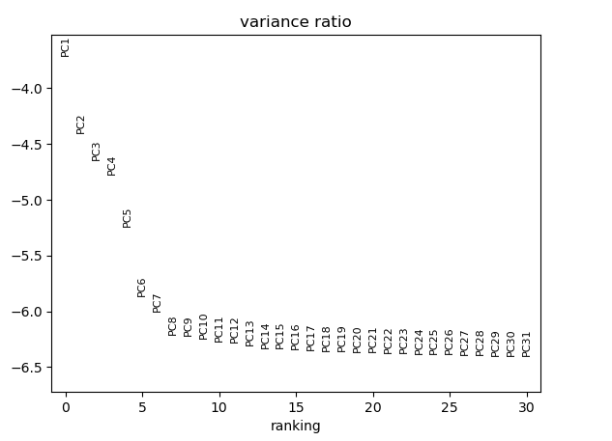
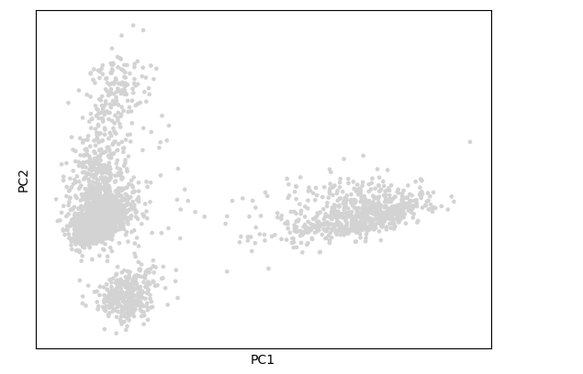

Each principal component is a combination of many genes.
A PC might reflect:
- cell type differences
- cell cycle state
- treatment effects
- batch effects
- immune activation
- technical variation

PC1 → direction with the most variation in the data
PC2 → direction with the second most variation

To figure out what PC1 or PC2 is “representing” biologically or technically in your PCA plot, you need to look at which genes contribute most to that principal component and what they do.

sc.pl.pca_loadings(adata)

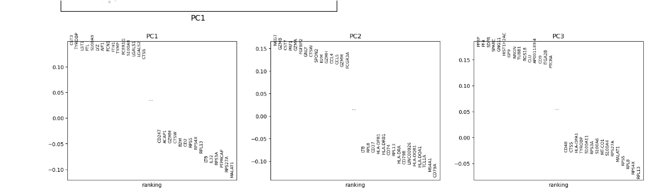

import pandas as pd

loadings = pd.DataFrame(adata.varm['PCs'], index=adata.var_names)
top_pc1_genes = loadings[0].sort_values(ascending=False).head(10)
top_pc2_genes = loadings[1].sort_values(ascending=False).head(10)

print("Top PC1 genes:\n", top_pc1_genes)
print("Top PC2 genes:\n", top_pc2_genes)

Top PC1 genes:
index
CST3 0.142670
TYROBP 0.134500
LST1 0.133072
FTL 0.132549
S100A9 0.132424
LYZ 0.132214
AIF1 0.131959
FCN1 0.131433
FTH1 0.129985
TYMP 0.126776
Name: 0, dtype: float64
Top PC2 genes:
index
NKG7 0.157991
GZMB 0.147663
CST7 0.147343
PRF1 0.147312
GZMA 0.145801
FGFBP2 0.138936
GNLY 0.131993
CTSW 0.131940
SPON2 0.119447
B2M 0.119361
Name: 1, dtype: float64

import scanpy as sc

# Load example PBMC dataset
adata = sc.datasets.pbmc3k()

# Mito genes usually start with 'MT-'
adata.var['mt'] = adata.var_names.str.startswith('MT-')

# Compute percent of counts in mitochondrial genes per cell
sc.pp.calculate_qc_metrics(adata, qc_vars=['mt'], percent_top=None, log1p=False, inplace=True)

import numpy as np

# Randomly assign T cells, B cells, NK cells
np.random.seed(42)
cell_types = np.random.choice(['T cell', 'B cell', 'NK cell'], size=adata.n_obs)
adata.obs['cell_type'] = cell_types

sc.pp.normalize_total(adata, target_sum=1e4)
sc.pp.log1p(adata)
sc.pp.highly_variable_genes(adata, min_mean=0.0125, max_mean=3, min_disp=0.5)
adata = adata[:, adata.var.highly_variable]
sc.pp.scale(adata, max_value=10)

sc.tl.pca(adata, svd_solver='arpack')
# Color by cell type
sc.pl.pca(adata, color='cell_type')

# Color by percent mitochondrial genes
sc.pl.pca(adata, color='pct_counts_mt')

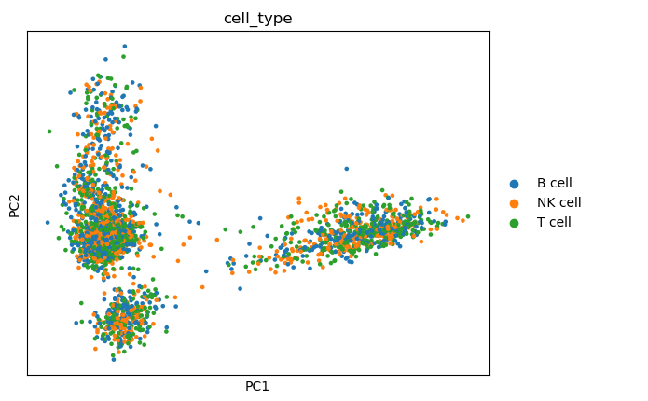

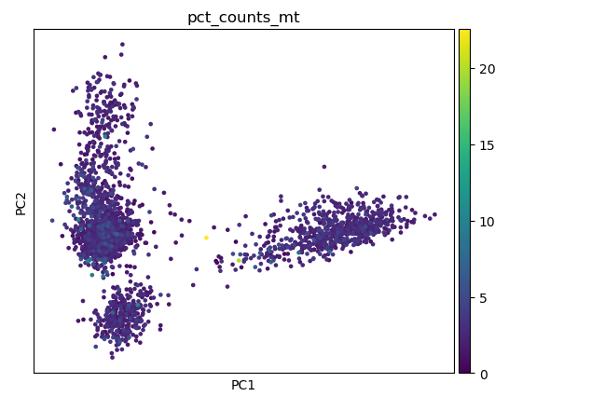

sc.tl.draw_graph(adata)
sc.pl.draw_graph(adata, color='cell_type')

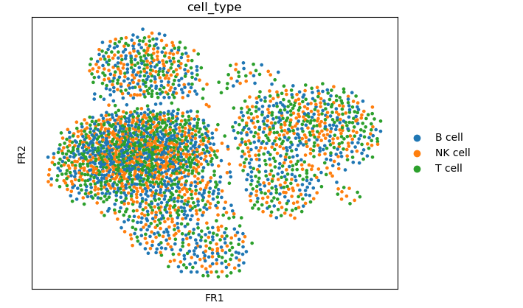

sc.tl.umap(adata) # compute UMAP
sc.pl.umap(adata, color='cell_type') # visualize

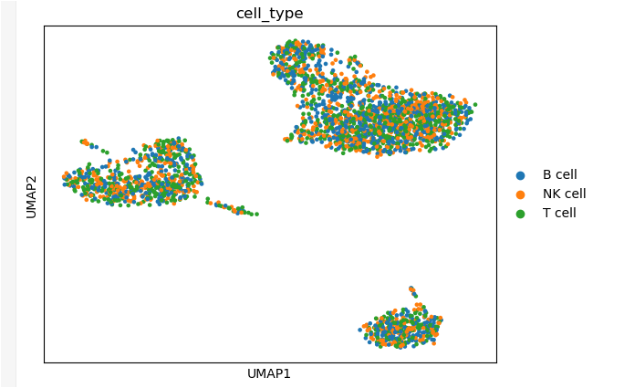

sc.tl.tsne(adata)
sc.pl.tsne(adata, color='cell_type')

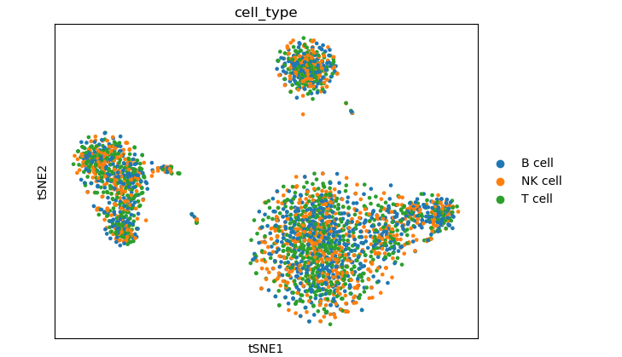

sc.tl.leiden(adata, resolution=0.5)
sc.pl.umap(adata, color=["leiden"])

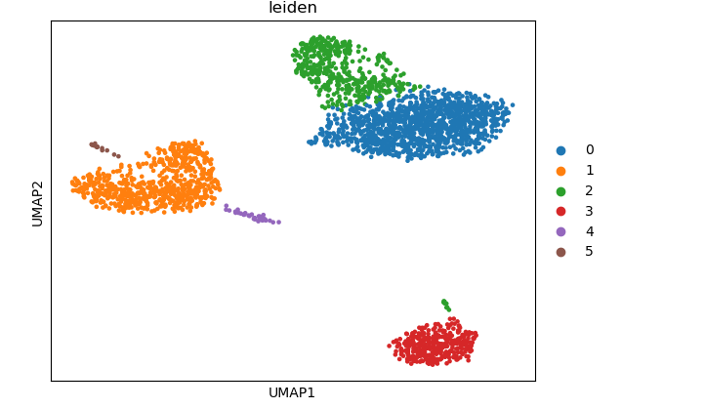

sc.pl.umap(adata, color=['CST3', 'TYROBP', 'LST1'])
